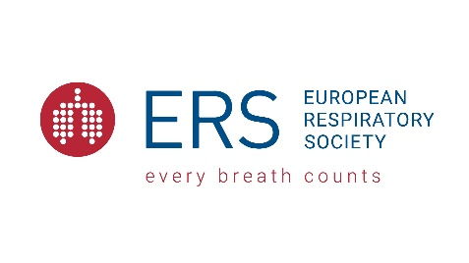
ERS Lifetime Achievement Award 2021
Application form
Kindly note that the reviewing will be conducted solely on the information contained in the below application form. Documentation attached to the application form will not be submitted for review (e.g. publication list or CV).

Personal details
Assembly | Only Assembly members 1,2,5,6 and 10 can apply for 2021
Title
First Name
Family Name
Date of birth (DD/MM/YYYY)
Nationality
Title of current working position
Name of current institution
City, Country
Email

Career Achievements & Past Contributions
Summary of the main career achievements, research, and contributions to the respiratory field:
3 pages max.
Academic Background
Academic background (most recent)
Degree (1) | (MD, PhD, MSc, Qualified allied respiratory, etc.)
Field of study (1)
Name of institute (1)
Degree (2) | (MD, PhD, MSc, Qualified allied respiratory, etc.)
Field of study (2)
Name of institute (2)
Degree (3) | (MD, PhD, MSc, Qualified allied respiratory, etc.)
Field of study (3)
Name of institute (3)
Other relevant information related to your academic background
100 words max.
Professional Experience
Professional Experience (top 5)
Name of position (1)
Name of institute (1)
Details relating to position (1) | 100 words max.
Name of position (2)
Name of institute (2)
Details relating to position (2) | 100 words max.
Name of position (3)
Name of institute (3)
Details relating to position (3) | 100 words max.
Name of position (4)
Name of institute (4)
Details relating to position (4) | 100 words max.
Name of position (5)
Name of institute (5)
Details relating to position (5) | 100 words max.
Other relevant information related to your professional experience
100 words max.
A short statement on personal contribution and engagement towards ERS
Contribution to ERS events or respective assembly, long-term member of ERS, reviewing of applications for ERS funding programmes, abstract accepted to ERS events, etc.
200 words max.
External or extra-curricular activities within the respiratory field (not ERS)
100 words max.
List of top ten original peer-reviewed publications (10 max.)

