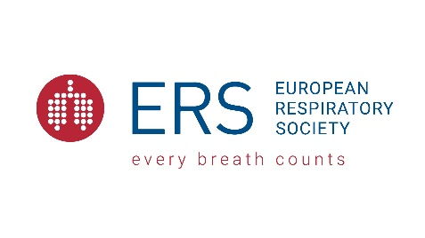
ERS Early-Career Member Award 2021
Application form
Kindly note that the reviewing will be conducted solely on the information contained in the below application form. Documentation attached to the application form will not be submitted for review (e.g. publication list or CV).

Personal details
Title
First Name
Family Name
Date of birth (DD/MM/YYYY)
Nationality
Title of current working position
Name of current institution
City, Country
Email

Career Achievements & Future Contribution
Future research plans and potential for further contribution to the respiratory field
1 page max.
Summary of main career achievements and research (inlc. previously obtained funding)
1 page max.
Academic Background
Academic background (most recent)
Degree (1) | (MD, PhD, MSc, Qualified allied respiratory, etc.)
Field of study (1)
Name of institute (1)
Degree (2) | (MD, PhD, MSc, Qualified allied respiratory, etc.)
Field of study (2)
Name of institute (2)
Degree (3) | (MD, PhD, MSc, Qualified allied respiratory, etc.)
Field of study (3)
Name of institute (3)
Other relevant information related to your academic background
100 words max.
Professional Experience
Professional Experience (top 5)
Name of position (1)
Name of institute (1)
Details relating to position (1) | 100 words max.
Name of position (2)
Name of institute (2)
Details relating to position (2) | 100 words max.
Name of position (3)
Name of institute (3)
Details relating to position (3) | 100 words max.
Name of position (4)
Name of institute (4)
Details relating to position (4) | 100 words max.
Name of position (5)
Name of institute (5)
Details relating to position (5) | 100 words max.
Other relevant information related to your professional experience
100 words max.
A short statement on personal contribution and engagement towards ERS
Contribution to ERS events or respective assembly, long-term member of ERS, reviewing of applications for ERS funding programmes, abstract accepted to ERS events, etc.
200 words max.
External or extra-curricular activities within the respiratory field (not ERS)
100 words max.
List of top ten original peer-reviewed publications (10 max.)
Highlight publications which were made independently from supervisors.
Work hiatus (if applicable)
Provide an explanation (parental leave, period working outside research, unemployment, etc.). The number of years taken for a work hiatus will be deducted from your age to obtain a “career age”.
100 words max.

